|  |  |
| --- | --- |
| |  | | --- | | Good morning **[First Name]**,  I’d be grateful -- and would really appreciate it -- if you would go to iTunes and give **Podcast Name** a rating and then write a review for our podcast. I respect your time so I wanted to make this as efficient as possible to find us in iTunes…so my team created a special link to save you time.  So if you go to **<link>** you will go directly to our channel within iTunes.  Okay, why am I asking for this favor?  With each rating and review we receive, **[First Name]**…you help us increase our rankings within iTunes -- and -- higher rankings means more people will see us in their search results -- and potentially they will be seeing us for the very first time.  Each and every review helps more and more people in more countries to hear the wisdom and expertise shared by our guests each day.  So, if you haven’t already given us a star rating and written a review — it would really mean a lot to me if you did.  It’s simple to do. It doesn’t take much time.  We’ve occasionally received feedback that leaving ratings can be a confusing process, so here are the steps in detail:  First, after going to the **<link>** link, please click the blue button that says “View in iTunes.”  <Change Image> | |

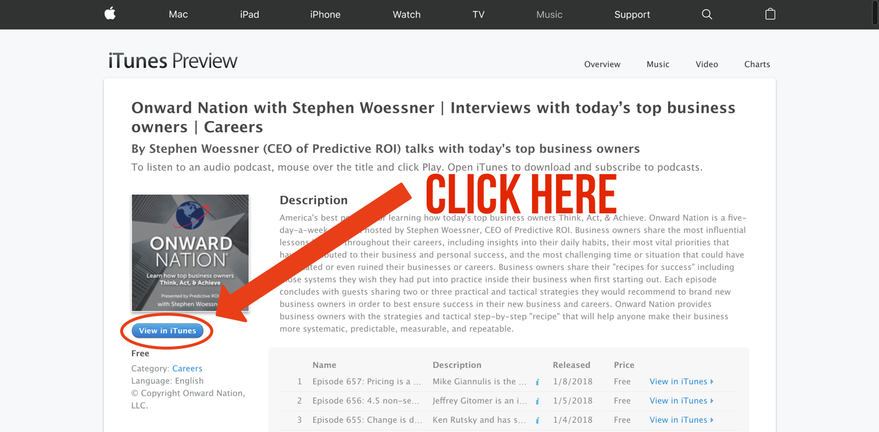

Next, click on the link titled “Ratings and Reviews.”

<Change Image>

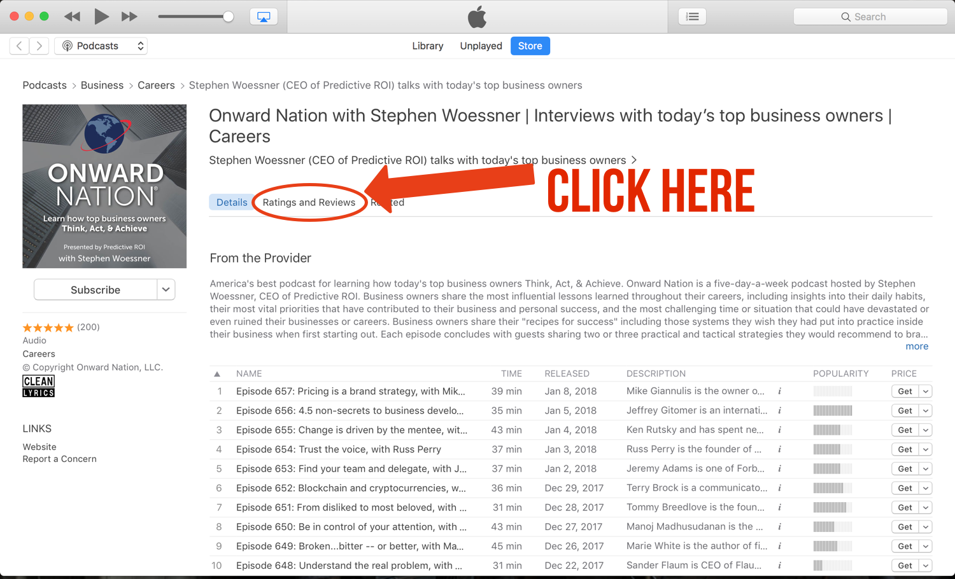

Next, click on “Write a Review.”

<Change Image>

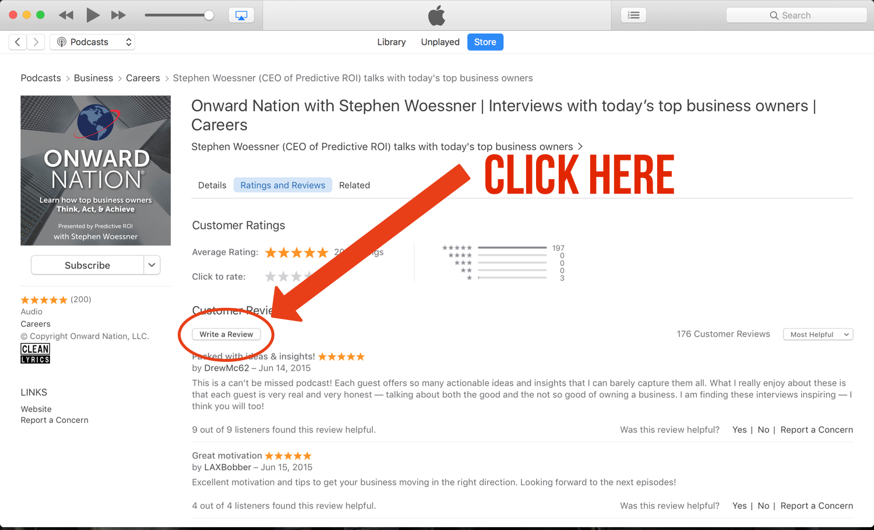

Finally, you will be able to leave a review. Don’t forget the star rating!

<Change Image>

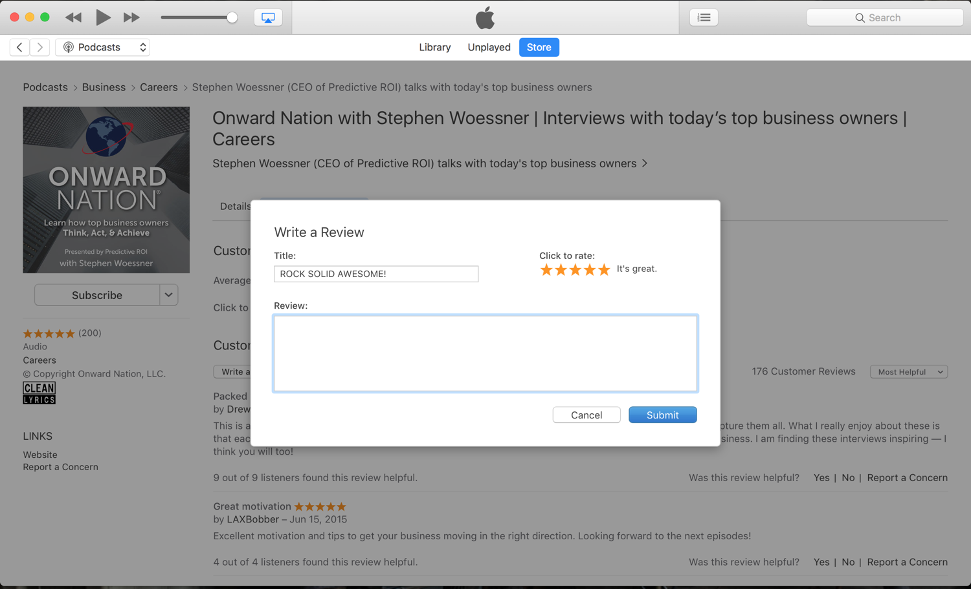

So thank you, **[First Name]** -- and please know -- I greatly appreciate all of your help, support, encouragement, and feedback -- you make me and my team better every day.

**[Signature]**